**Name:- Dnyaneshwar Parmeshwar Pawar.**

**Mobile:- 9011429678.**

**Email:-** [**dnyaneshpawar1212@gmail.com**](mailto:dnyaneshpawar1212@gmail.com)

**Assignment:- Junior Quality Analyst Assignment**

**Objective**: This assignment is designed to evaluate your understanding and skills in testing web applications, SaaS platforms, and mobile apps. Please follow the instructions carefully and submit your responses within [insert time frame, e.g., 48 hours].

**Part 1: Web Application Testing**

**Test Case 1:**

**Login with valid data (Positive Test Case)**

**Description:** Verify that a user log in with valid email and password.  
**Steps:**

1. User is on login page.
2. Enter a valid email in the email input field**. ( test123@.com)**
3. Enter the correct password in the password input field**. ( pass123)**
4. Click the "Login" button.

**Expected Result:** user is navigate to the dashboard page.

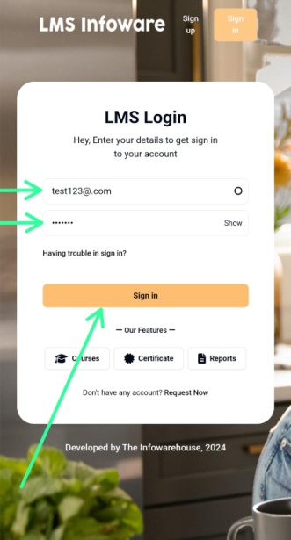

**Test Case 2:**

**Login with Invalid data (Negative Test Case)**

**Description:** Verify that the user notable log in with a invalid email and invalid password.  
**Steps:**

1. User is on login page.
2. Enter a valid email in the email input field**. (#$%$@gmail.com)**
3. Enter an incorrect password in the password input field**. (%$#$#)**
4. Click the "Login" button.

**Expected Result:** An error message is displayed (e.g., "Invalid email or password").

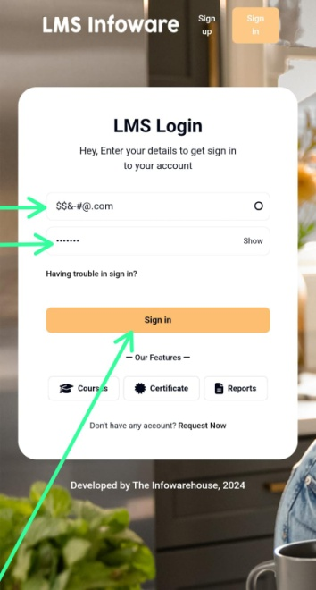

**User entered Invalid Inputs**

**Test Case 3:**

**Login with Empty Email and Password (Negative Test Case)**

**Description:** Verify that user keep login fields (email and password) blank.  
**Steps:**

1. User is on login page.
2. Leave both the email and password fields blank.
3. Click the "Login" button.

**Expected Result:** An error message is displayed for both fields ("Email is required" and "Password is required").

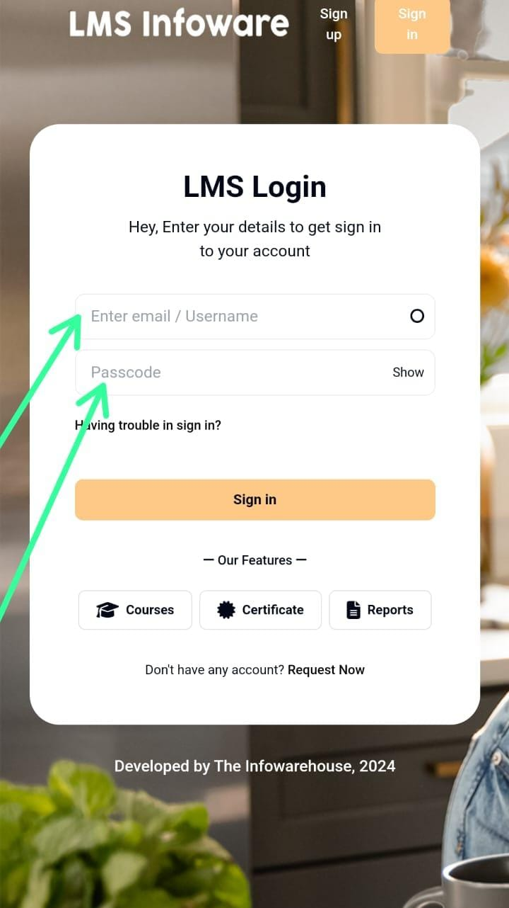

**User Keep login field Empty**

**Test Case 4:**

**Login with Invalid Email Format (Negative Test Case)**

**Description:** Verify that email field will not accept an invalid format.  
**Steps:**

1. User is on login page.
2. Enter an invalid email in the email input field. **(….user@com)**
3. Enter a valid password in the password input field. **(Password123)**
4. Click the "Login" button.

**Expected Result:** An error message is displayed ("Please enter a valid email address").

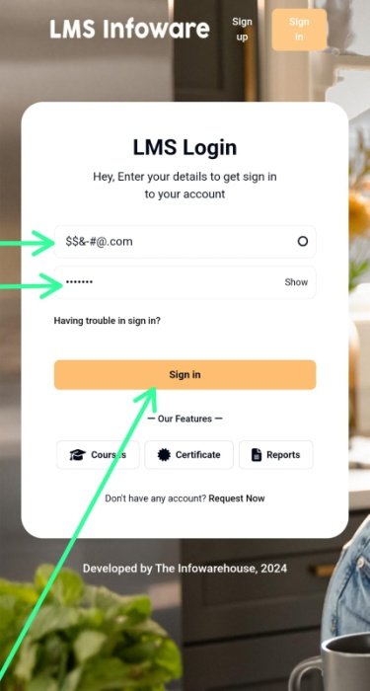

**User Entered Invalid Email format**

**Test Case 5:**

**Login with SQL Injection Attempt (Security Test Case)**

**Description:** Verify the login page is protected against SQL injection attacks.  
**Steps:**

1. User is on login page.
2. Enter the email input field.**("' OR '1'='1")**
3. Enter value in the password input field.
4. Click the "Login" button.

**Expected Result:** 1**.** An page should display an error message ("Invalid email or password").

**Part 2: SaaS Application Testing**

**Risk 1: Data Loss or Corruption.**

**Description:** When multiple users create, update, or assign tasks simultaneously, there’s a risk of data corruption or overwriting due to concurrency issues.

**Mitigation:**

**Backup and Recovery Testing:** Test the system’s ability to back up task data and recover it in case of data corruption or failure.

**Risk 2: Real-Time Notifications.**

**Description:** The real-time notification system may fail to deliver updates due to server-side issues, poor connectivity, or incompatible device.

**Mitigation:**

**Monitoring and Alerts:** Implement monitoring to detect and resolve notification failures in real time.

**Risk 3: Lack of Compatibility Across Browsers and Devices**

**Description:** Users may access the SaaS platform from various browsers and devices..

**Mitigation:**

**Cross-Browser Testing:** Test the application on major browsers (Chrome, Firefox, Safari, Edge) .

**Part 3: Bug Reporting**

**Bug Title:**  
"Forgot Password" Link on Login Page is Not Clickable

**Steps to Reproduce:**

1. Open the web application in a browser (Chrome, Firefox).
2. User navigates to the login page.
3. "Forgot Password" link below the email and password input fields.
4. User clicks the "Forgot Password" link.

**Actual Result:** User not able to clickonForgot Password Link.

**Expected Result:** After Clicking **u**ser should navigate to the Forgot Password page.

**Severity:**  
**Medium** – The issue affects core functionality for users who need to recover their password but does not block other critical functions.

**Priority:**  
**High** – This impacts user experience and could prevent users from accessing their accounts.

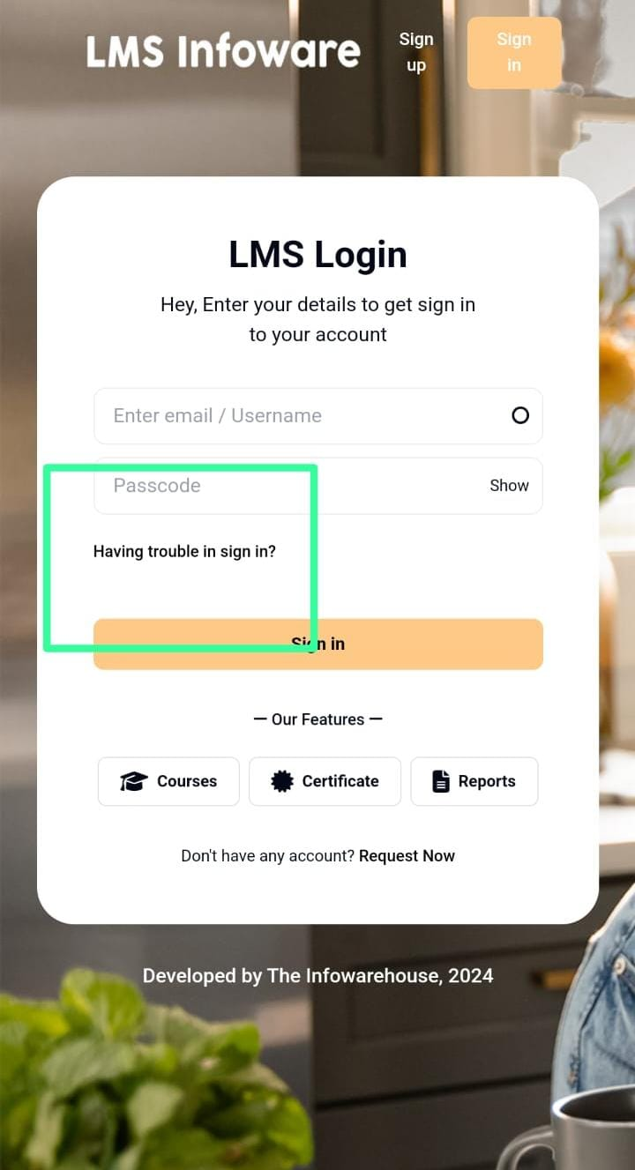

**User not able to click on Forgot Password Link.**

**Additional Information:**

1. **Browser Version:**

Google Chrome Version 118.0.5993.88

Mozilla Firefox Version 119.0.1

1. **Operating System:**

Windows 10 (Version 22H2)